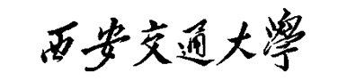

课 程 实 验 报 告

实验名称： 非二次规划问题直线搜索

姓名: 林圣翔
学号: 2223312202
专业班级: 计试2201
指导教师: 罗敏楠教授
报告日期: 2025.10.19



一、实验目的
1.研究梯度下降法中不同直线搜索策略对收敛性能的影响。
2.提升科学计算和结果可视化的实践能力。

二、实验内容

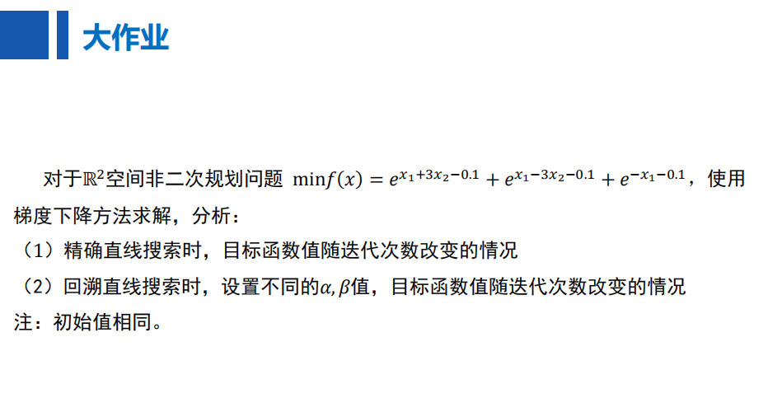

实验环境
1.系统环境：基于Ubuntu 20.04.6 LTS版本
2.编程语言：Python 3.10

四、实验过程
- 环境配置
1.1.创建 Conda 虚拟环境
conda create -n YHFFJC python=3.10
1.2.激活 Conda 虚拟环境
conda activate YHFFJC
1.3.安装项目依赖包
pip install -r requirements.txt
- 代码实现
2.1.具体函数及其功能如下表所示
函数模块 | 函数名 | 功能描述
核心数学函数 | function(x) | 计算目标函数值：f(x) = exp(x₁+ 3x₂- 0.1) + exp(x₁- 3x₂- 0.1) + exp(-x₁- 0.1)
 | gradient(x) | 计算目标函数的梯度向量[∂f/∂x₁, ∂f/∂x₂]
 | hessian(x) | 计算目标函数的Hessian矩阵（二阶导数矩阵）
搜索方向函数 | neg_gradient_direction(x) | 计算负梯度方向（最速下降方向）
 | newton_direction(x) | 计算牛顿方向：-H⁻¹∇f(x)
 | p_norm_direction(x, P) | 计算P-范数方向：-P⁻¹∇f(x)，其中P为预条件矩阵
线搜索方法 | exact_line_search(x, direction) | 精确线搜索：在给定方向上最小化目标函数
 | backtracking_line_search(x, direction, alpha, beta) | 回溯线搜索：Armijo条件满足时停止
 | gradient_descent_exact(x0, ...) | 使用精确线搜索的梯度下降法，返回最优解、误差序列和轨迹
 | gradient_descent_backtracking(x0, ...) | 使用回溯线搜索的梯度下降法，返回最优解、误差序列和轨迹
参数优化和分析 | grid_search_backtracking(x0, ...) | 对回溯线搜索参数α和β进行网格搜索
 | calculate_convergence_rate(errors) | 基于最后几次迭代计算收敛速率
可视化函数 | plot_3d_surface_and_trajectory(x0, ...) | 绘制3D表面图和等高线图，显示优化轨迹
 | plot_results(all_errors, title, filename) | 绘制收敛曲线（对数尺度）
 | plot_grid_search_results(df_results, filename) | 绘制网格搜索结果的多个热力图
 | plot_exact_line_search() | 对不同初始点运行精确线搜索并绘图
 | plot_backtracking_line_search() | 对不同参数运行回溯线搜索并绘图
 | plot_exact_vs_backtracking() | 比较精确线搜索和回溯线搜索的性能
 | main_grid_search() | 执行回溯线搜索参数的网格搜索分析
 | plot_comprehensive_3d_visualization() | 绘制的3D和等高线可视化
2.2.主函数执行流程
2.2.1.调用plot_comprehensive_3d_visualization()函数
对于精确直线搜索，选取初始点[1,2]、[2,-3]、[-3,2]、[-2,-1]，评估算法从不同区域出发的收敛特性。对于回溯直线搜索，取初始点为[1,1]，参数[α、β]组合取[0.1,0.3]、[0.3,0.5]、[0.5,0.8]，这些组合代表了从保守到激进的步长选择策略。通过绘制三维表面与二维等高线迭代轨迹，直观展示优化算法在目标函数曲面上的搜索路径和收敛行为。
2.2.2.调用plot_exact_line_search()函数
该函数对四个初始点[1,2]、[2,-3]、[-3,2]、[-2,-1]分别运行精确线搜索算法，记录每个点的优化轨迹和收敛过程。通过绘制误差收敛曲线和生成3D轨迹图，系统分析精确线搜索在不同初始条件下的收敛速度、迭代次数和最终精度。
2.2.3.调用plot_backtracking_line_search()函数
实验设计三组参数测试：固定α变化β、固定β变化α、双参数协同变化。通过系统测试不同参数组合下的算法性能，绘制多组收敛曲线对比图，分析Armijo条件参数α和步长缩减因子β对收敛特性的影响。
2.2.4.调用main_grid_search()函数
在α和β参数的广泛取值范围内进行网格搜索，对81种参数组合进行系统性能评估。通过生成最终误差、迭代次数和收敛速率三个热力图，从不同角度识别最优参数组合，并为最佳参数生成3D轨迹验证图。
2.2.5.调用plot_exact_vs_backtracking()函数
在相同初始点[1,1]和收敛准则下，比较精确线搜索与两组回溯线搜索参数[α=0.1,β=0.3]和[α=0.5,β=0.3]的性能差异。
- 运行代码
执行如下命令，程序依次完成步骤2.2.1-2.2.5。
python run.py

五、实验结果
1.精确直线搜索
1.1.三维表面与二维等高线迭代轨迹
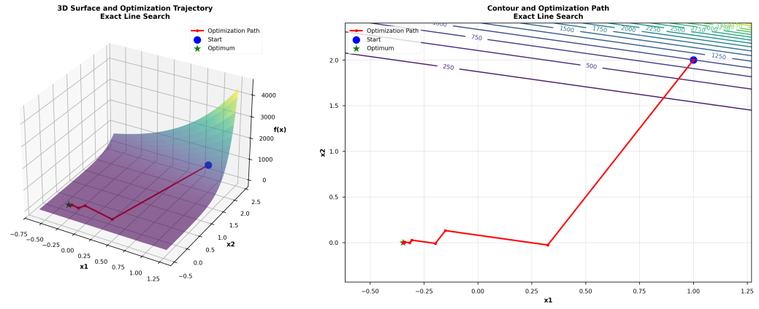
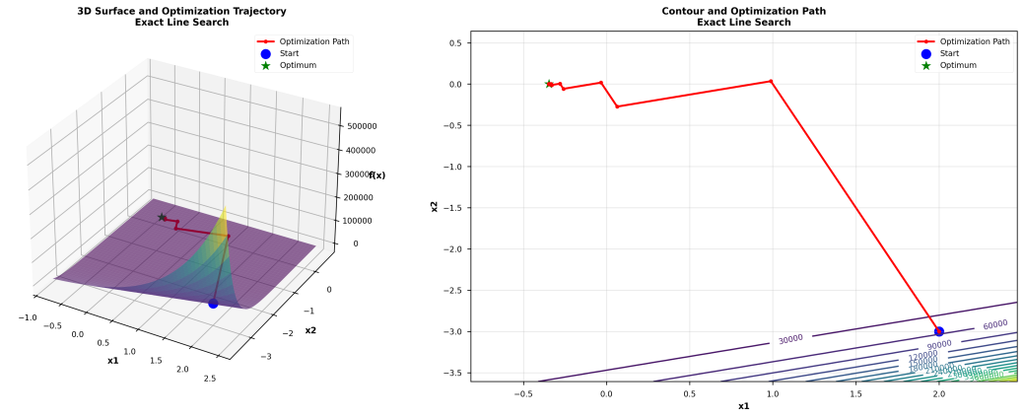
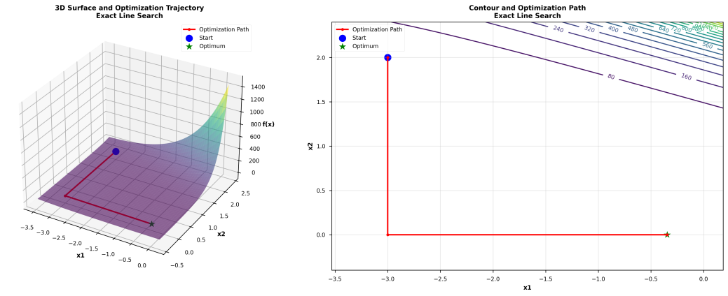
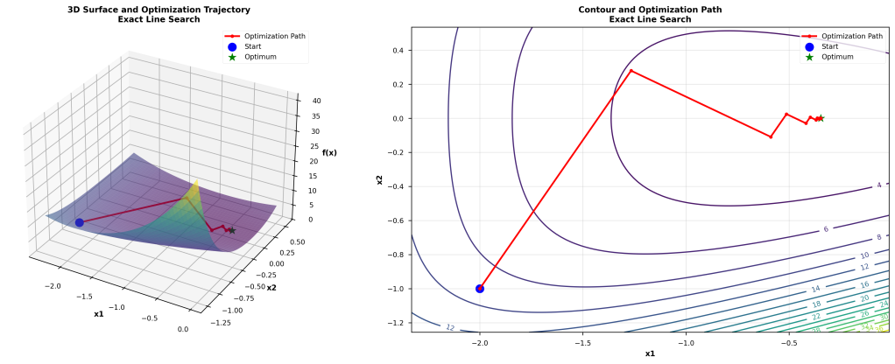
1.2.不同初始点下的收敛性分析
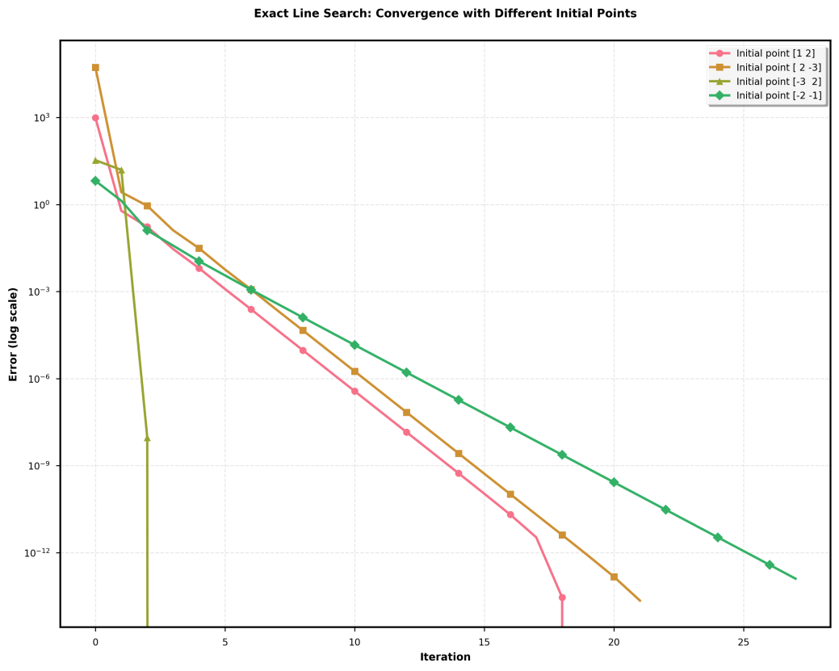
不同初始点下的收敛结果
初始点 | 最优解 | 最优值 | 迭代次数
[1,2] | [-3.46573898e-01, 3.31938272e-08] | 2.55926670 | 20
[2,-3] | [-3.46573898e-01, 3.31938272e-08] | 2.55926670 | 22
[-3,2] | [-3.46573898e-01, 3.31938272e-08] | 2.55926670 | 4
[-2,-1] | [-3.46573898e-01, 3.31938272e-08] | 2.55926670 | 28

2.回溯直线搜索
2.1.三维表面与二维等高线迭代轨迹
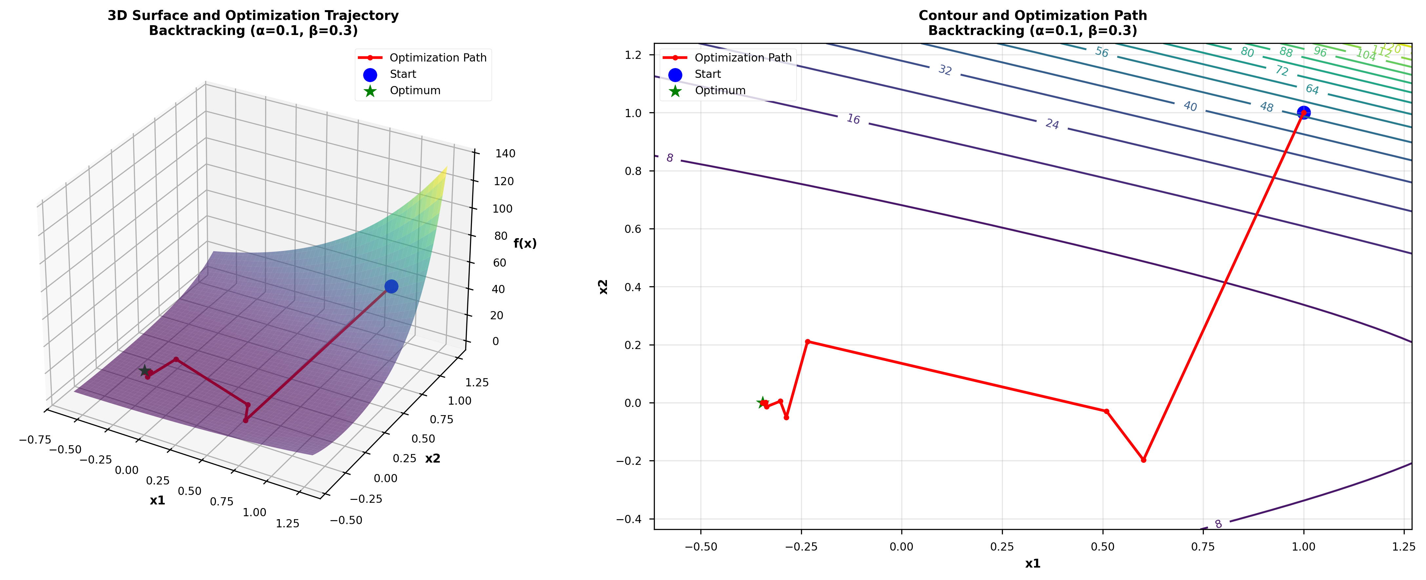
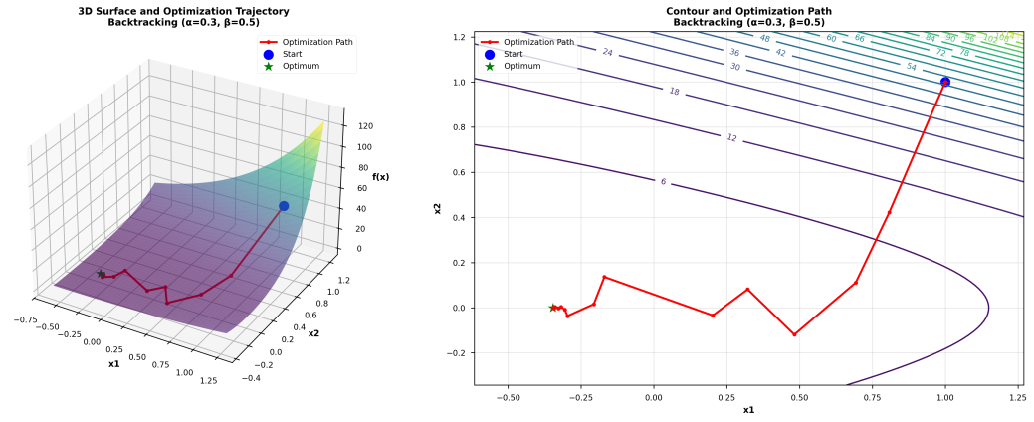
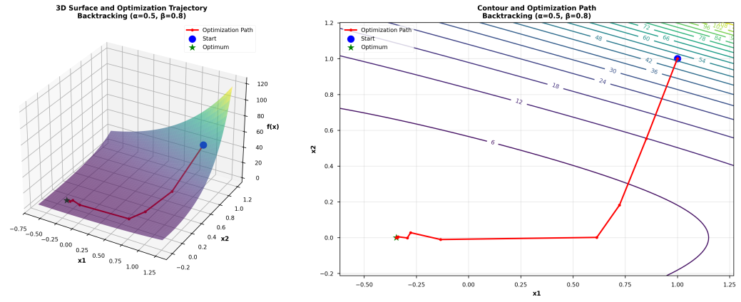
2.2.不同参数组合（α、β）下的收敛性分析
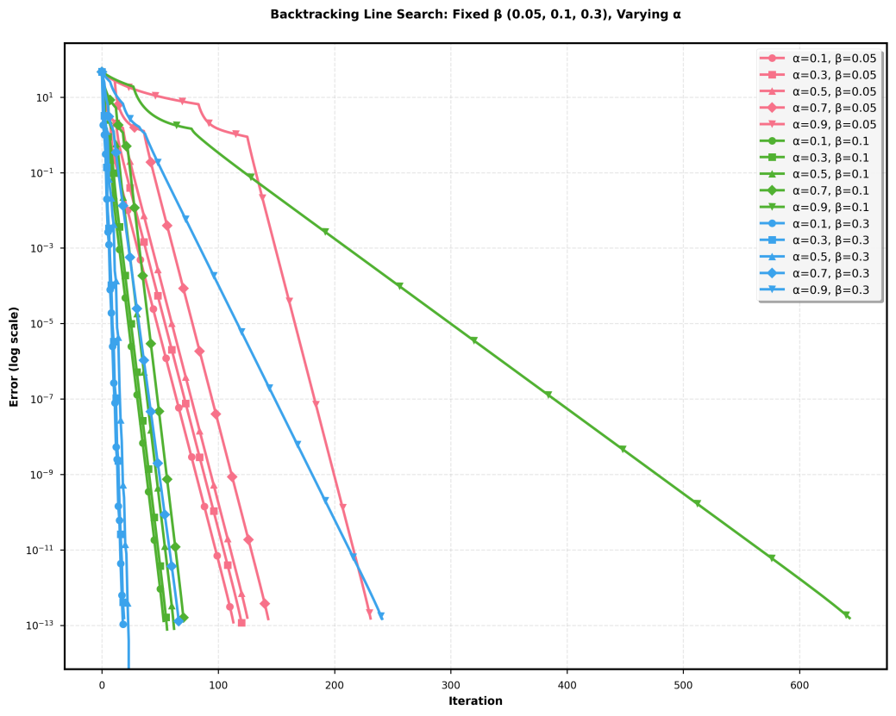
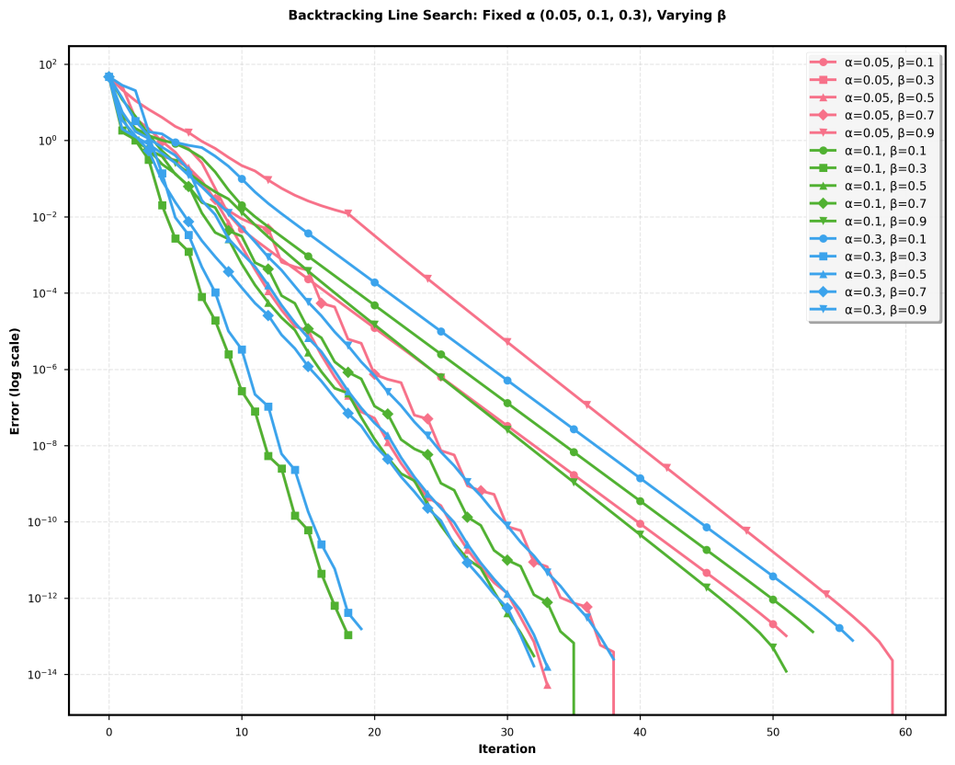
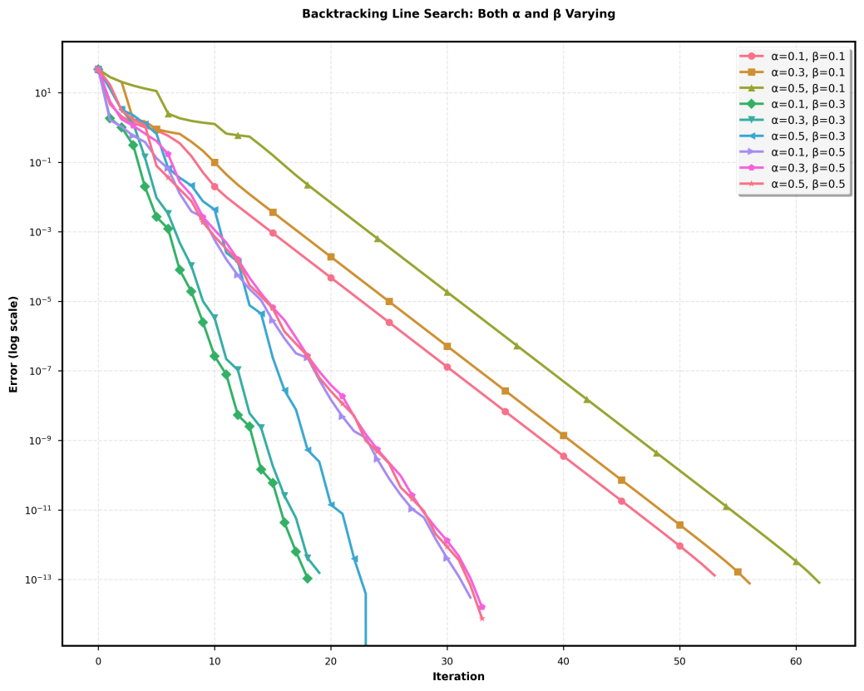
所有搜索结果最优值均为2.55926670
2.3.网格搜索寻找最优参数组合（α、β）
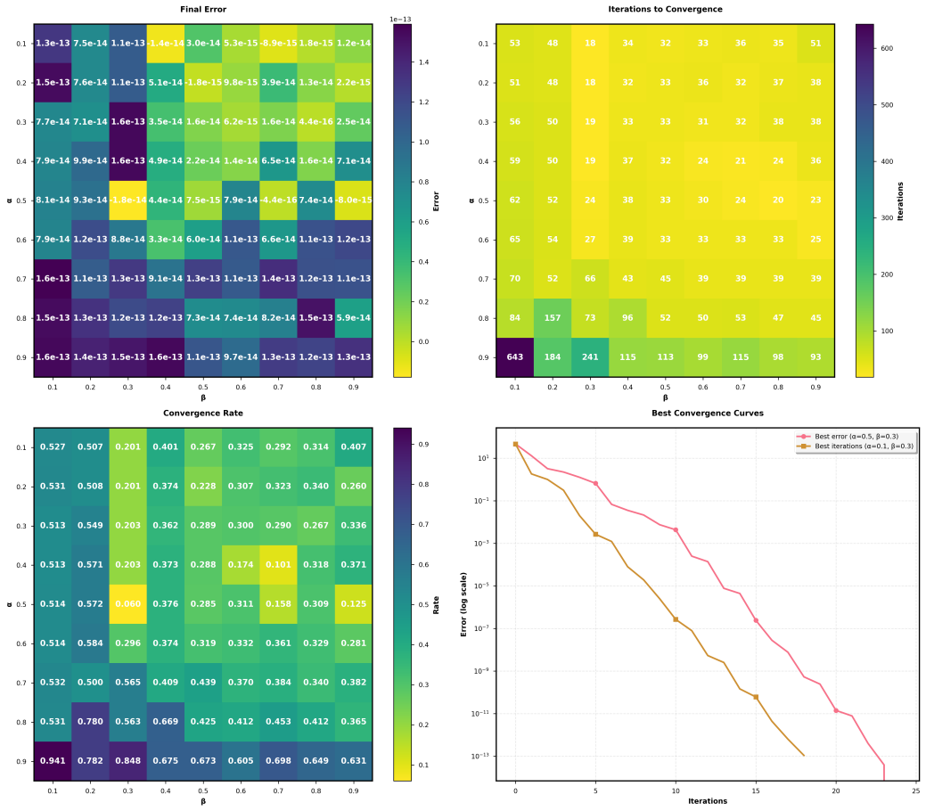
当α=0.5、β=0.3时，误差最小。
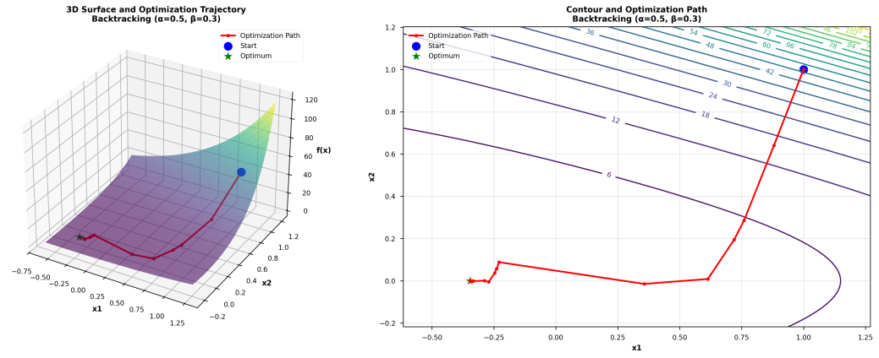
当α=0.1、β=0.3时，迭代轮次最小。


3.精确直线搜索和回溯直线搜索对比（初始值相同,均为[1,1]）
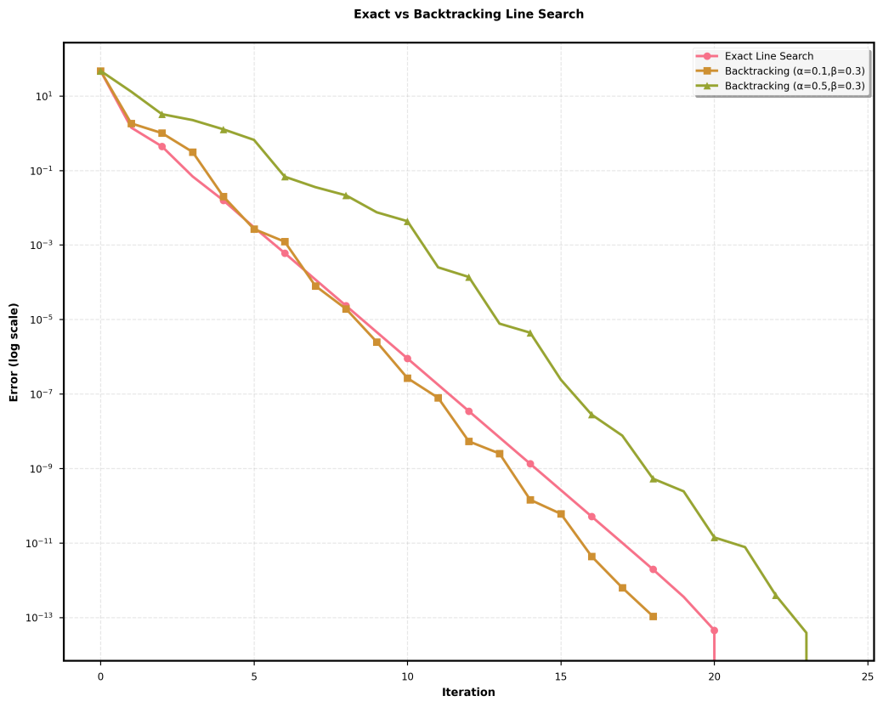

实验结论
- 实验中，精确线搜索在不同初始点均能收敛，但路径差异显著。回溯线搜索中，保守参数（α=0.1,β=0.3）轨迹密集稳定，激进参数（α=0.5,β=0.8）收敛更快但波动较大。可视化验证了算法在目标函数曲面上的有效收敛性。
- 精确线搜索在所有初始点均达到高精度最优解，收敛稳定。初始点[1,2]收敛最快，[-2,-1]较慢，反映函数在不同区域的梯度特性差异。收敛曲线显示误差呈指数下降，验证了最优步长选择特性。
- α和β对算法性能影响显著。小α（0.05）稳定但慢，大α（0.9）可能不稳定；小β（0.1）迭代多，大β（0.9）可能错过最优。最优参数为α=0.3、β=0.5，平衡收敛速度与稳定性。
- 网格搜索确定最优参数区域为α∈[0.1,0.4]、β∈[0.3,0.7]。推荐组合α=0.3、β=0.5，在保证精度的同时具有较快收敛速度，表现出良好的数值稳定性。
- 精确线搜索迭代次数少但单步成本高；回溯线搜索[α=0.1,β=0.3]稳定适合高精度，[α=0.5,β=0.3]平衡效率。根据问题需求选择：高精度用精确线搜索，效率优先用回溯线搜索。

附录：
requirements.txt
scipy
scikit-learn
pandas
matplotlib
orange3
seaborn
run.py
import numpy as np
import matplotlib.pyplot as plt
from scipy.optimize import minimize, minimize_scalar
import os
import itertools
import pandas as pd
import seaborn as sns

plt.style.use('seaborn-v0_8-paper')
sns.set_palette("husl")
COLORS = sns.color_palette("husl", 8)
MARKERS = ['o', 's', '^', 'D', 'v', '<', '>', 'p']

if not os.path.exists('result'):
os.makedirs('result')

def function(x):
return np.exp(x[0] + 3 * x[1] - 0.1) + np.exp(x[0] - 3 * x[1] - 0.1) + np.exp(-x[0] - 0.1)

def gradient(x):
df_dx1 = (np.exp(x[0] + 3 * x[1] - 0.1) + np.exp(x[0] - 3 * x[1] - 0.1) - np.exp(-x[0] - 0.1))
df_dx2 = 3 * np.exp(x[0] + 3 * x[1] - 0.1) - 3 * np.exp(x[0] - 3 * x[1] - 0.1)
return np.array([df_dx1, df_dx2])

def hessian(x):
e1 = np.exp(x[0] + 3 * x[1] - 0.1)
e2 = np.exp(x[0] - 3 * x[1] - 0.1)
e3 = np.exp(-x[0] - 0.1)
h11 = e1 + e2 + e3
h12 = 3 * (e1 - e2)
h22 = 9 * (e1 + e2)
return np.array([[h11, h12], [h12, h22]])

def neg_gradient_direction(x):
return -gradient(x)

def newton_direction(x):
hess = hessian(x)
grad = gradient(x)
return -np.linalg.inv(hess).dot(grad)

def p_norm_direction(x, P=np.array([[2, 1], [1, 2]])):
grad = gradient(x)
return -np.linalg.inv(P).dot(grad)

def exact_line_search(x, direction):
def g(alpha):
return function(x + alpha * direction)
result = minimize_scalar(g)
return result.x

def backtracking_line_search(x, direction, alpha=0.3, beta=0.8):
step_size = 1.0
while function(x + step_size * direction) > function(x) + alpha * step_size * np.dot(gradient(x), direction):
step_size *= beta
return step_size

def gradient_descent_exact(x0, max_iter=10000, tol=1e-6, direction_func=neg_gradient_direction):
x = x0.copy()
p_star = minimize(function, x0).fun
errors = [function(x) - p_star]
trajectory = [x.copy()]
for k in range(max_iter):
direction = direction_func(x)
step_size = exact_line_search(x, direction)
x = x + step_size * direction
trajectory.append(x.copy())
error = function(x) - p_star
grad_norm = np.linalg.norm(gradient(x), 2)
errors.append(error)
if grad_norm < tol:
break
return x, errors, trajectory

def gradient_descent_backtracking(x0, alpha=0.3, beta=0.8, max_iter=10000, tol=1e-6, direction_func=neg_gradient_direction):
x = x0.copy()
p_star = minimize(function, x0).fun
errors = [function(x) - p_star]
trajectory = [x.copy()]
for k in range(max_iter):
direction = direction_func(x)
step_size = backtracking_line_search(x, direction, alpha, beta)
x = x + step_size * direction
trajectory.append(x.copy())
error = function(x) - p_star
grad_norm = np.linalg.norm(gradient(x), 2)
errors.append(error)
if grad_norm < tol:
break
return x, errors, trajectory

def grid_search_backtracking(x0, alpha_values=[0.1, 0.2, 0.3, 0.4], beta_values=[0.1, 0.3, 0.5, 0.7, 0.9], max_iter=10000, tol=1e-6, direction_func=neg_gradient_direction):
results = []
for alpha, beta in itertools.product(alpha_values, beta_values):
x_opt, errors, trajectory = gradient_descent_backtracking(x0, alpha=alpha, beta=beta, max_iter=max_iter, tol=tol, direction_func=direction_func)
final_error = errors[-1]
iterations = len(errors) - 1
convergence_rate = calculate_convergence_rate(errors) if len(errors) > 5 else float('inf')
results.append({
'alpha': alpha,
'beta': beta,
'final_error': final_error,
'iterations': iterations,
'convergence_rate': convergence_rate,
'optimal_value': function(x_opt),
'errors': errors,
'trajectory': trajectory
})
print(f"α={alpha}, β={beta}: iterations={iterations}, final_error={final_error:.2e}")
df_results = pd.DataFrame(results)
best_by_error = df_results.loc[df_results['final_error'].idxmin()]
best_by_iterations = df_results.loc[df_results['iterations'].idxmin()]
print("\n=== Grid Search Results ===")
print(f"Best by final error: α={best_by_error['alpha']}, β={best_by_error['beta']}, error={best_by_error['final_error']:.2e}")
print(f"Best by iterations: α={best_by_iterations['alpha']}, β={best_by_iterations['beta']}, iterations={best_by_iterations['iterations']}")
return df_results

def calculate_convergence_rate(errors):
if len(errors) < 5:
return float('inf')
last_errors = errors[-5:]
rates = []
for i in range(1, len(last_errors)):
if last_errors[i-1] > 0:
rate = last_errors[i] / last_errors[i-1]
rates.append(rate)
return np.mean(rates) if rates else float('inf')

def plot_3d_surface_and_trajectory(x0, method_name, params=None, filename=None):
if method_name == "exact":
x_opt, errors, trajectory = gradient_descent_exact(x0)
title_suffix = "Exact Line Search"
elif method_name == "backtracking":
if params is None:
params = {'alpha': 0.3, 'beta': 0.8}
x_opt, errors, trajectory = gradient_descent_backtracking(x0, alpha=params['alpha'], beta=params['beta'])
title_suffix = f"Backtracking (α={params['alpha']}, β={params['beta']})"
trajectory_x1 = [point[0] for point in trajectory]
trajectory_x2 = [point[1] for point in trajectory]
trajectory_z = [function(point) for point in trajectory]
x1_min, x1_max = min(trajectory_x1), max(trajectory_x1)
x2_min, x2_max = min(trajectory_x2), max(trajectory_x2)
margin_x1 = (x1_max - x1_min) * 0.2
margin_x2 = (x2_max - x2_min) * 0.2
x1_range = np.linspace(x1_min - margin_x1, x1_max + margin_x1, 100)
x2_range = np.linspace(x2_min - margin_x2, x2_max + margin_x2, 100)
X1, X2 = np.meshgrid(x1_range, x2_range)
Z = np.zeros_like(X1)
for i in range(X1.shape[0]):
for j in range(X1.shape[1]):
Z[i, j] = function([X1[i, j], X2[i, j]])
fig = plt.figure(figsize=(16, 6))
ax1 = fig.add_subplot(121, projection='3d')
surf = ax1.plot_surface(X1, X2, Z, cmap='viridis', alpha=0.6, linewidth=0, antialiased=True)
ax1.plot(trajectory_x1, trajectory_x2, trajectory_z, 'ro-', linewidth=2, markersize=4, label='Optimization Path')
ax1.scatter(trajectory_x1[0], trajectory_x2[0], trajectory_z[0], color='blue', s=100, marker='o', label='Start')
ax1.scatter(trajectory_x1[-1], trajectory_x2[-1], trajectory_z[-1], color='green', s=100, marker='*', label='Optimum')
ax1.set_xlabel('x1', fontweight='bold')
ax1.set_ylabel('x2', fontweight='bold')
ax1.set_zlabel('f(x)', fontweight='bold')
ax1.set_title(f'3D Surface and Optimization Trajectory\n{title_suffix}', fontweight='bold')
ax1.legend()
ax2 = fig.add_subplot(122)
contour = ax2.contour(X1, X2, Z, levels=20, cmap='viridis')
ax2.clabel(contour, inline=True, fontsize=8)
ax2.plot(trajectory_x1, trajectory_x2, 'ro-', linewidth=2, markersize=4, label='Optimization Path')
ax2.scatter(trajectory_x1[0], trajectory_x2[0], color='blue', s=100, marker='o', label='Start')
ax2.scatter(trajectory_x1[-1], trajectory_x2[-1], color='green', s=100, marker='*', label='Optimum')
ax2.set_xlabel('x1', fontweight='bold')
ax2.set_ylabel('x2', fontweight='bold')
ax2.set_title(f'Contour and Optimization Path\n{title_suffix}', fontweight='bold')
ax2.legend()
ax2.grid(True, alpha=0.3)
plt.tight_layout()
if filename is None:
filename = f"3d_contour_{method_name}_x0_{x0[0]}_{x0[1]}.png"
filepath = os.path.join('result', filename)
plt.savefig(filepath, dpi=300, bbox_inches='tight', facecolor='white')
plt.close()
print(f"3D surface and contour plot saved: {filepath}")
return trajectory

def plot_results(all_errors, title, filename, figsize=(10, 8)):
fig, ax = plt.subplots(figsize=figsize)
for i, (errors, label) in enumerate(all_errors):
if len(errors) > 0:
ax.semilogy(range(len(errors)), errors,
color=COLORS[i % len(COLORS)],
marker=MARKERS[i % len(MARKERS)],
markersize=6,
markevery=max(1, len(errors)//10),
linewidth=2,
label=label)
ax.set_xlabel('Iteration', fontweight='bold')
ax.set_ylabel('Error (log scale)', fontweight='bold')
ax.set_title(title, fontweight='bold', pad=20)
ax.legend(frameon=True, fancybox=True, shadow=True, framealpha=0.9)
ax.grid(True, alpha=0.3, linestyle='--')
for spine in ax.spines.values():
spine.set_linewidth(1.5)
filepath = os.path.join('result', filename)
plt.tight_layout()
plt.savefig(filepath, dpi=300, bbox_inches='tight', facecolor='white')
plt.close()
print(f"Figure saved: {filepath}")

def plot_grid_search_results(df_results, filename):
fig, axes = plt.subplots(2, 2, figsize=(16, 14))
alpha_vals = sorted(df_results['alpha'].unique())
beta_vals = sorted(df_results['beta'].unique())
error_matrix = df_results.pivot(index='alpha', columns='beta', values='final_error')
im1 = axes[0, 0].imshow(error_matrix, cmap='viridis_r', aspect='auto')
axes[0, 0].set_title('Final Error', fontweight='bold', pad=15)
axes[0, 0].set_xlabel('β', fontweight='bold')
axes[0, 0].set_ylabel('α', fontweight='bold')
axes[0, 0].set_xticks(range(len(beta_vals)))
axes[0, 0].set_xticklabels(beta_vals)
axes[0, 0].set_yticks(range(len(alpha_vals)))
axes[0, 0].set_yticklabels(alpha_vals)
cbar1 = plt.colorbar(im1, ax=axes[0, 0])
cbar1.set_label('Error', fontweight='bold')
for i in range(len(alpha_vals)):
for j in range(len(beta_vals)):
axes[0, 0].text(j, i, f'{error_matrix.iloc[i, j]:.1e}',
ha="center", va="center", color="w", fontsize=10, fontweight='bold')
iter_matrix = df_results.pivot(index='alpha', columns='beta', values='iterations')
im2 = axes[0, 1].imshow(iter_matrix, cmap='viridis_r', aspect='auto')
axes[0, 1].set_title('Iterations to Convergence', fontweight='bold', pad=15)
axes[0, 1].set_xlabel('β', fontweight='bold')
axes[0, 1].set_ylabel('α', fontweight='bold')
axes[0, 1].set_xticks(range(len(beta_vals)))
axes[0, 1].set_xticklabels(beta_vals)
axes[0, 1].set_yticks(range(len(alpha_vals)))
axes[0, 1].set_yticklabels(alpha_vals)
cbar2 = plt.colorbar(im2, ax=axes[0, 1])
cbar2.set_label('Iterations', fontweight='bold')
for i in range(len(alpha_vals)):
for j in range(len(beta_vals)):
axes[0, 1].text(j, i, f'{iter_matrix.iloc[i, j]:.0f}',
ha="center", va="center", color="w", fontsize=10, fontweight='bold')
rate_matrix = df_results.pivot(index='alpha', columns='beta', values='convergence_rate')
im3 = axes[1, 0].imshow(rate_matrix, cmap='viridis_r', aspect='auto')
axes[1, 0].set_title('Convergence Rate', fontweight='bold', pad=15)
axes[1, 0].set_xlabel('β', fontweight='bold')
axes[1, 0].set_ylabel('α', fontweight='bold')
axes[1, 0].set_xticks(range(len(beta_vals)))
axes[1, 0].set_xticklabels(beta_vals)
axes[1, 0].set_yticks(range(len(alpha_vals)))
axes[1, 0].set_yticklabels(alpha_vals)
cbar3 = plt.colorbar(im3, ax=axes[1, 0])
cbar3.set_label('Rate', fontweight='bold')
for i in range(len(alpha_vals)):
for j in range(len(beta_vals)):
if rate_matrix.iloc[i, j] < float('inf'):
axes[1, 0].text(j, i, f'{rate_matrix.iloc[i, j]:.3f}',
ha="center", va="center", color="w", fontsize=10, fontweight='bold')
axes[1, 1].set_title('Best Convergence Curves', fontweight='bold', pad=15)
best_by_error = df_results.loc[df_results['final_error'].idxmin()]
best_by_iter = df_results.loc[df_results['iterations'].idxmin()]
axes[1, 1].semilogy(best_by_error['errors'], color=COLORS[0], marker='o', markersize=6, markevery=5,
linewidth=2, label=f'Best error (α={best_by_error["alpha"]}, β={best_by_error["beta"]})')
axes[1, 1].semilogy(best_by_iter['errors'], color=COLORS[1], marker='s', markersize=6, markevery=5,
linewidth=2, label=f'Best iterations (α={best_by_iter["alpha"]}, β={best_by_iter["beta"]})')
axes[1, 1].set_xlabel('Iterations', fontweight='bold')
axes[1, 1].set_ylabel('Error (log scale)', fontweight='bold')
axes[1, 1].legend(frameon=True, fancybox=True, shadow=True, framealpha=0.9)
axes[1, 1].grid(True, alpha=0.3, linestyle='--')
for ax_row in axes:
for ax in ax_row:
for spine in ax.spines.values():
spine.set_linewidth(1.5)
plt.tight_layout()
filepath = os.path.join('result', filename)
plt.savefig(filepath, dpi=300, bbox_inches='tight', facecolor='white')
plt.close()
print(f"Grid search results saved: {filepath}")
return best_by_error, best_by_iter

def plot_exact_line_search():
print("=== Exact Line Search - Different Initial Points ===")
initial_points = [
np.array([1, 2]),
np.array([2, -3]),
np.array([-3, 2]),
np.array([-2, -1])
]
all_errors = []
for i, x0 in enumerate(initial_points):
print(f"\nInitial point {i+1}: {x0}")
optimal_x, errors, trajectory = gradient_descent_exact(x0)
all_errors.append((errors, f'Initial point {x0}'))
print(f"Optimal solution: {optimal_x}")
print(f"Optimal value: {function(optimal_x):.8f}")
print(f"Iterations: {len(errors)}")
if i < 3:
plot_3d_surface_and_trajectory(x0, "exact", filename=f"exact_line_search_trajectory_{i+1}.png")
plot_results(all_errors, 'Exact Line Search: Convergence with Different Initial Points', 'exact_line_search_initial_points.png')

def plot_backtracking_line_search():
print("\n=== Backtracking Line Search - Different Parameters ===")
param_groups = [
[(alpha, beta) for alpha in [0.05, 0.1, 0.3] for beta in [0.1, 0.3, 0.5, 0.7, 0.9]],
[(alpha, beta) for beta in [0.05, 0.1, 0.3] for alpha in [0.1, 0.3, 0.5, 0.7, 0.9]],
[(alpha, beta) for beta in [0.1, 0.3, 0.5] for alpha in [0.1, 0.3, 0.5]],
]
group_names = [
'Fixed α (0.05, 0.1, 0.3), Varying β',
'Fixed β (0.05, 0.1, 0.3), Varying α',
'Both α and β Varying'
]
filenames = [
'backtracking_fixed_alpha.png',
'backtracking_fixed_beta.png',
'backtracking_both_changing.png'
]
x0 = np.array([1.5, 1.5])
example_params = [
{'alpha': 0.1, 'beta': 0.3},
{'alpha': 0.3, 'beta': 0.8},
{'alpha': 0.5, 'beta': 0.5}
]
for i, params in enumerate(example_params):
plot_3d_surface_and_trajectory(
x0, "backtracking", params,
filename=f"backtracking_trajectory_example_{i+1}.png"
)
for group_idx, params in enumerate(param_groups):
print(f"\n--- Parameter Group {group_idx+1}: {group_names[group_idx]} ---")
all_errors = []
x0 = np.array([1, 1])
if group_idx == 0:
alphas = sorted(set(alpha for alpha, beta in params))
alpha_colors = sns.color_palette("husl", len(alphas))
color_map = {alpha: alpha_colors[i] for i, alpha in enumerate(alphas)}
markers = ['o', 's', '^', 'D', 'v']
elif group_idx == 1:
betas = sorted(set(beta for alpha, beta in params))
beta_colors = sns.color_palette("husl", len(betas))
color_map = {beta: beta_colors[i] for i, beta in enumerate(betas)}
markers = ['o', 's', '^', 'D', 'v']
else:
color_map = None
markers = ['o', 's', '^', 'D', 'v', '<', '>', 'p', '*']
color_list = []
marker_list = []
label_list = []
errors_list = []
for i, (alpha, beta) in enumerate(params):
optimal_x, errors, trajectory = gradient_descent_backtracking(x0, alpha=alpha, beta=beta)
if group_idx == 0:
label = f'α={alpha}, β={beta}'
color = color_map[alpha]
marker = markers[i % 5]
elif group_idx == 1:
label = f'α={alpha}, β={beta}'
color = color_map[beta]
marker = markers[i % 5]
else:
label = f'α={alpha}, β={beta}'
color = COLORS[i % len(COLORS)]
marker = markers[i % len(markers)]
errors_list.append(errors)
label_list.append(label)
color_list.append(color)
marker_list.append(marker)
print(f"α={alpha}, β={beta}: iterations={len(errors)}, optimal value={function(optimal_x):.8f}")
fig, ax = plt.subplots(figsize=(10, 8))
for i, (errors, label, color, marker) in enumerate(zip(errors_list, label_list, color_list, marker_list)):
if len(errors) > 0:
ax.semilogy(range(len(errors)), errors, color=color, marker=marker,markersize=6, markevery=max(1, len(errors)//10), linewidth=2, label=label)
ax.set_xlabel('Iteration', fontweight='bold')
ax.set_ylabel('Error (log scale)', fontweight='bold')
ax.set_title(f'Backtracking Line Search: {group_names[group_idx]}', fontweight='bold', pad=20)
ax.legend(frameon=True, fancybox=True, shadow=True, framealpha=0.9, fontsize=9)
ax.grid(True, alpha=0.3, linestyle='--')
for spine in ax.spines.values():
spine.set_linewidth(1.5)
filepath = os.path.join('result', filenames[group_idx])
plt.tight_layout()
plt.savefig(filepath, dpi=300, bbox_inches='tight', facecolor='white')
plt.close()
print(f"Figure saved: {filepath}")

def plot_exact_vs_backtracking():
print("\n=== Exact vs Backtracking Line Search ===")
x0 = np.array([1, 1])
all_errors = []
optimal_x_exact, errors_exact, trajectory_exact = gradient_descent_exact(x0)
all_errors.append((errors_exact, 'Exact Line Search'))
print(f"Exact Line Search: iterations={len(errors_exact)}, optimal value={function(optimal_x_exact):.8f}")
backtracking_params = [(0.1, 0.3), (0.5, 0.3)]
for alpha, beta in backtracking_params:
optimal_x_bt, errors_bt, trajectory_bt = gradient_descent_backtracking(x0, alpha=alpha, beta=beta)
all_errors.append((errors_bt, f'Backtracking (α={alpha},β={beta})'))
print(f"Backtracking (α={alpha},β={beta}): iterations={len(errors_bt)}, optimal value={function(optimal_x_bt):.8f}")
plot_results(all_errors, 'Exact vs Backtracking Line Search', 'exact_vs_backtracking.png')
plot_3d_surface_and_trajectory(x0, "exact", filename="comparison_exact.png")
plot_3d_surface_and_trajectory(x0, "backtracking", {'alpha': 0.1, 'beta': 0.3}, filename="comparison_backtracking.png")

def main_grid_search():
print("\n=== Grid Search for Backtracking Parameters ===")
x0 = np.array([1.0, 1.0])
alpha_values = [0.1, 0.2, 0.3, 0.4, 0.5, 0.6, 0.7, 0.8, 0.9]
beta_values = [0.1, 0.2, 0.3, 0.4, 0.5, 0.6, 0.7, 0.8, 0.9]
df_results = grid_search_backtracking(x0, alpha_values, beta_values)
best_by_error, best_by_iter = plot_grid_search_results(df_results, 'grid_search_results.png')
print("\n=== Creating 3D Visualization for Best Parameters ===")
plot_3d_surface_and_trajectory(
x0, "backtracking",
{'alpha': best_by_error['alpha'], 'beta': best_by_error['beta']},
filename="grid_search_best_by_error.png"
)
plot_3d_surface_and_trajectory(
x0, "backtracking",
{'alpha': best_by_iter['alpha'], 'beta': best_by_iter['beta']},
filename="grid_search_best_by_iterations.png"
)
csv_path = os.path.join('result', 'grid_search_results.csv')
df_results.to_csv(csv_path, index=False)
print(f"Detailed results saved to: {csv_path}")
return best_by_error, best_by_iter

def plot_comprehensive_3d_visualization():
print("\n=== Creating Comprehensive 3D Visualizations ===")
initial_points = [
np.array([1, 2]),
np.array([2, -3]),
np.array([-3, 2]),
np.array([-2, -1])
]
for i, x0 in enumerate(initial_points):
plot_3d_surface_and_trajectory(x0, "exact", filename=f"comprehensive_exact_x0_{i+1}.png")
backtracking_params = [
{'alpha': 0.1, 'beta': 0.3},
{'alpha': 0.3, 'beta': 0.5},
{'alpha': 0.5, 'beta': 0.8}
]
x0 = np.array([1.0, 1.0])
for i, params in enumerate(backtracking_params):
plot_3d_surface_and_trajectory(x0, "backtracking", params,filename=f"comprehensive_backtracking_params_{i+1}.png")

plot_comprehensive_3d_visualization()
plot_exact_line_search()
plot_backtracking_line_search()
main_grid_search()
plot_exact_vs_backtracking()

